Isometric Training: Science and Practical Applications

Strength training exercises generally involve concentric and eccentric muscle actions where muscle lengthens and shortens, respectively, when exerting force against the resistance. Another mode of strength training that is gaining popularity in recent years is isometric training (IST), which involves the generation of force without any external movement. However, despite the lack of external movement, muscle fascicles are actually shortening and tendons lengthen during isometric actions (Ito et al., 1998). In addition, two different types of isometric muscle actions have been identified: hold isometric muscle action (HIMA) – maintaining a joint angle while resisting an external load, and push isometric muscle action (PIMA) – exerting force against an immovable object (Schaefer & Bittmann, 2017) (Figure 1). While the two isometric muscle actions have been identified to have differences in neural control, little is known about the difference in neuromuscular adaptations between the two types of isometric muscle action.
The earliest known study on IST was conducted by Hettinger and Muller in 1953. Back then, the authors concluded that muscle strength can improve by 5% per week by using around 65% of maximal isometric force for as little as a single 6 second daily effort. Since then, numerous studies have been conducted to investigate the neuromuscular and morphological adaptations to IST (Lum and Barbosa, 2019). Despite the numerous studies showing the effectiveness of IST on strength adaptations, IST has not been widely used for sports performance enhancement until recent years. A possible reason is that few studies on IST have measured sports performance. The recent increase in studies from our lab showing the effectiveness in enhancing sports performance by including IST may have contributed to the raise in IST’s popularity. In this blog, Danny Lum will discuss the neuromuscular adaptations of IST, its effects on various sports performance parameters, and provide recommendations for training prescription.
Dose-Response to Isometric Strength Training
Factors affecting strength gains and muscle hypertrophy from strength training include frequency, intensity, and volume of training, inter-repetition and inter-set rest periods, and speed of muscular contraction / action. Manipulating these factors while performing IST also leads to different neuromuscular chronic adaptations.
It has been shown that 6 weeks to 100 days of IST training resulted in 5.4-23% increase in muscle cross-sectional area accompanied by up to 91.7% increase in strength (Lum and Barbosa, 2019). The magnitude of muscle hypertrophy from each study was associated with the duration of the intervention training, with a longer intervention period showing higher magnitude of muscle hypertrophy. Other factors affecting the magnitude of hypertrophy included training intensity and volume, contraction / action duration and muscle length at which isometric contraction / action occurred during training. With that being said, it has been shown that IST, which required a sustained contraction / action for >3 s per repetition, resulted in greater amount of muscle hypertrophy as compared to the protocols which only required sustaining contraction for 1-3 s, even when volume and intensity of training were equalised (Schott et al., 1995).
While the hypertrophy adaptation is mainly determined by duration of sustained contraction / action , strength adaptation is mainly affected by the intensity of contraction/ action . For example, a protocol that involves 10 repetitions of 5 s isometric contraction / action at 100% maximum voluntary contraction (MVC) would result in greater strength gain than a protocol involving 4 repetitions of 2 min isometric contraction / action at 20-30% MVC (Hagberg et al., 2000).
The concept of “if you want to move fast, you need to train fast” also applies to IST. It has been established that in order to increase rate of force development by training with IST, individuals will have to perform each contraction / action as rapidly as possible. For example, a protocol that involved rapid but no sustained contraction (~1 s), was previously found to result in greater improvement in explosive strength than a protocol that used a ramp up and sustained contraction protocol in two studies (Balshaw et al., 2016; Tillin & Folland, 2014). However, these two studies also reported lower level of strength increment with the rapid contraction protocol. In a more recent study from our lab, we found that when the rapid contraction protocol included a 3 s sustained contraction, there would be a concurrent improvement in both maximum and explosive strength (Lum et al., 2021b).
Based on current findings in the literature, it is recommended that IST be performed at >70% of MVC with sustained contraction of 3-30s per repetition, and a total sustained contraction duration of > 80–150 s per session when the objective is to increase hypertrophy. Both hold and push isometric action can be used for this purpose (Figure 1 & 2). If the objective is to increase maximum strength, IST should be performed at 80–100% MVC with a with sustained contraction of 1–5 s, and a total contraction time of 30–90 s per session. Exercise performed with push isometric action would be recommended for this as it allows for maximal contraction. In order to improve explosive strength, IST should be performed with rapid contraction (i.e. as contract as fast as possible) with short contraction duration (1-3 s). Individuals may meet this objective by performing both hold and push isometric actions rapidly (Figure 3 & 4).
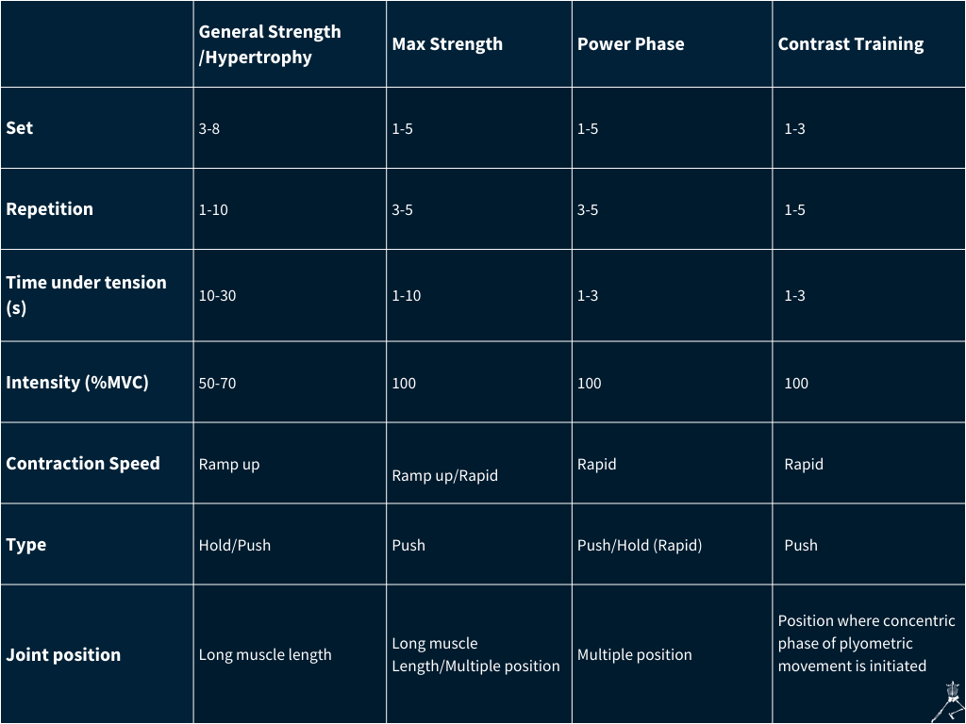Table 1 | Guide to implementing isometric training for various neuromuscular adaptations..
Influence of Joint Position on Adaptations to Isometric Strength Training
One of the misconceptions about IST is that it only results in strength increment at the position where training occurs. What studies have shown is that IST can resulted in strength increment in other joint positions between 20º-45º away from the joint position adopted during training (Alegre et al., 2014; Kubo et al., 2006; Noorkoiv et al., 2015). And the range of positions at which strength increases is dependent on the length of the muscle during IST, with training at longer muscle length resulting in strength increment throughout greater range of movement. For example, performing isometric knee extension at 80º knee angle (180º = full extension), where the quadriceps muscles were stretched to longer length, was reported to increase strength at 60º-140º knee angles while performing the same training at 130º knee angle only resulted in strength increment from 100º-140º knee angle (Kubo et al., 2006). Furthermore, dynamic strength was also reported to improve to a larger extend when IST was performed at long muscle length as compared to short muscle length (Alegre et al., 2014; Noorkoiv et al., 2015). This makes sense, as force generation ability is improved at greater range of joint positions, greater amount of force can be generated as the limbs goes through a given range of movement.
Apart from increasing strength through a greater range of movement, performing IST at long muscle lengths also leads to greater morphological adaptations. Several studies have reported that performing IST at long muscle lengths resulted in greater muscular hypertrophy than when IST was performed at short muscle lengths (Alegre et al., 2014; Kubo et al., 2006; Noorkoiv et al., 2015). Furthermore, performing IST at long muscle lengths also resulted in greater hypertrophy and tendon stiffness (Kubo et al., 2006). This may have some practical implications for sports performance as tendon stiffness is associated with greater rate of force development and shorter contact time during drop jump (Abdelsattar et al., 2018). In addition, these adaptations may also key component for running economy in endurance events.
While performing IST at long muscle lengths seems to provide more favourable strength and morphological adaptations as compared to training at short muscle length, results from our recent study showed that performing IST across multiple positions / joint angles as compared to one long muscle length position, may have greater benefit to the performance of ballistic movement (Lum et al., 2022). In this study, we showed that participants who performed isometric bench press at three different positions / joint angle configurations resulted in greater peak power during ballistic push up as compared to those who only performed isometric bench press at 90º elbow angle. This is despite similar improvement in 1 repetition maximum bench press. The most likely explanation for this is that 1 repetition maximum bench press was mostly determined by the amount of force that an individual can produced at the sticking region (~90º elbow angle). As both groups had performed training at that position, they would have similar improvement in force generation capability at that position. As the ballistic push up was an action that required the body to accelerate throughout the full range of movement, specifically training at different ranges / configurations would have resulted in greater strength improvement through a greater range of movement as compared to simply training at one position. Hence, it would seem that individuals should consider performing IST across multiple positions when the objective is to improve ballistic movement performance, especially when IST is not performed in concurrent with other dynamic modes of resistance training.
Based on current evidence, it is recommended that to perform IST at joint positions that induce long muscle lengths to increase strength throughout a greater range of movement and also to increase morphological adaptations. However, if the objective is to enhance a specific dynamic movement, it will be better to perform IST across multiple joint positions.
Combining Isometric Training with other modes of Strength Training
While performing IST may result in strength increment, it may not be the best in improving dynamic strength (which is a skill) as compared to dynamic mode of strength training (Lum & Barbosa, 2019). A possible reason could be due to the differences in neuromuscular control of isometric vs dynamic actions. For example, during isometric actions, while there is no external movement, muscle fascicles are actually shortening while tendons are lengthening. While in a rapid ballistic movement like a countermovement jump, the muscles are in a quasi-isometric state so that the tendon is stretched when the joints move. As the principle of specificity applies, when the objective is to improve performance of dynamic movements, individuals are still required to perform dynamic mode of training to optimise adaptations. Nevertheless, the inclusion of IST can still enhance the overall adaptations as compared to performing dynamic training alone. There has been evidence from several studies showing that the combination of IST and dynamic strength training as compared to dynamic strength training alone resulted in greater improvement in strength and dynamic movements (Lum et al., 2021a; Lum et al., 2023; McPartlan et al., 2021). For example, replacing half the volume of heavy resistance squat exercises with isometric squat has been shown to result in greater strength, sprint and countermovement jump performance across a 24-week period (Lum et al., 2023a). Hence, coaches who plan to include IST into their athletes’ training programme can do this by replacing a certain volume (e.g. 1-3 sets) of dynamic heavy resistance training for a specific exercise with the isometric mode (Table 2).
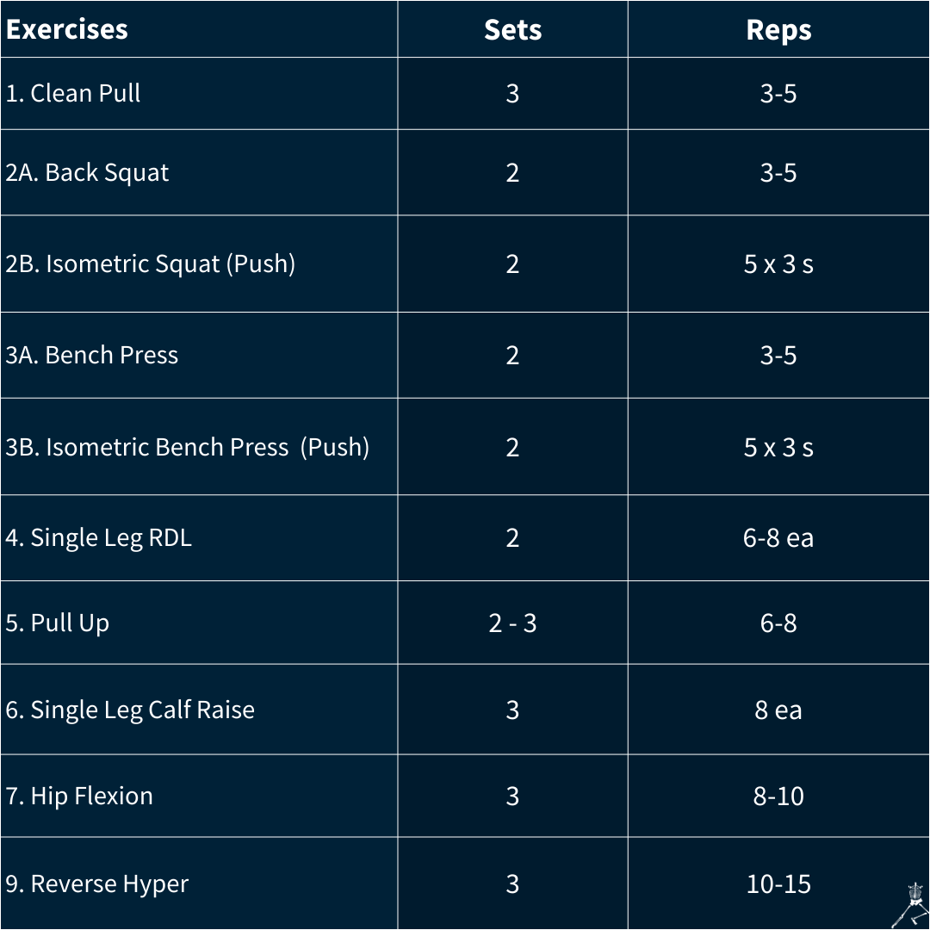Table 2 | Training programme with the inclusion of isometric training for
back squat and bench press exercises.
The difference in neuromuscular adaptations between dynamic strength training and IST were likely complementary to each other which led to greater performance enhancing effect.
Dynamic training such as plyometric training is effective in increasing active muscle stiffness (i.e. ability to maintain quasi-isometric state) which allows the tendon to stretch rapidly during the countermovement phase of dynamic movement. Thus, resulting in higher amount of elastic energy stored in the tendon which leads to greater production of propulsion force. In contrast, IST has a better effect on tendon stiffness. While high active muscle stiffness allows for great tendon stretch during countermovement phase of a movement, high tendon stiffness would result in greater storage of elastic energy when stretched and reduced electromechanical delay, resulting in greater propulsive force generated. Hence, there is a complementary effect on neuromuscular adaptations when IST is performed in concurrent with dynamic training.
Apart from replacing certain volume of dynamic mode of strength training with IST, inclusion of IST into a training programme can also be done in the form of complex / contrast training. Recently, there has been some studies reporting the positive post-activation performance (PAPE) effect of isometric muscle contraction /action (Lum et al., 2023b; Krzysztofik et al., 2023; Spieszny et al., 2023). These studies showed that performing rapid and low volume of isometric contraction / actions at positions similar to the action of interest (e.g. using isometric squat to potentiate countermovement jump) could enhance the performance of the given dynamic movement (e.g. increase jump height, lifting velocity etc). Figure 5 illustrates an example of contrast isometric and plyometric training for lower limb.
Figure 5 | Contrast training that pairs isometric trapbar deadlift and countermovement jump.
Summary
The effectiveness of complex / contrast training is well documented in the literature, and is often reported to be more effective in improving strength and power than traditional strength training. The advantage of using isometric contraction as a PAPE activity during a complex contrast training as compared to heavy resistance exercise is the lower fatiguing effect. Hence, reducing the recovery time required between the conditioning exercise and subsequent ballistic action. Furthermore, less amount of time is required for individuals to recover to baseline strength after performing IST as compared to heavy resistance training. This means that coaches may plan for their athletes to use IST as a conditioning activity during in-season or competition phase so as to reduce athletes’ level of fatigue while still able to maintain or make some gains in neuromuscular adaptations. In summary:
- Adaptations to IST are influenced by factors such as joint position, rate and intensity of contraction / action and time under tension.
- The inclusion of IST with dynamic strength training may lead to better neuromuscular adaptations due to the complementary effect of the different adaptations from each mode of training.
- The inclusion of IST can be done by replacing a certain volume of a dynamic exercise with the isometric mode.
- IST can also be performed as a form of conditioning activity to induce PAPE for subsequent ballistic movement during a complex contrast training set.

